**Communities and Education Directorate**

**Arran High School**

**Improvement Plan 2021-2022**





**Vision, Values and Aims**

* **Ambition Belonging Compassion Trust**

Our school exists to provide a safe, aspirational learning environment for every young person and to uphold our school values in all aspects of school life. In doing so, we provide the opportunity for each individual to express their unique skills, attributes and capabilities to achieve at the highest level in all of their endeavours.

**The North Ayrshire Annual Improvement Plan**

The North Ayrshire Education annual improvement plan sets out our priorities for the year ahead in pursuit of the joint aims of achieving excellence and equity for our learners. It takes account of the feedback from consultation with our stakeholders across the Council and community and ensures the delivery of the locally agreed priorities of the Council Plan and the nationally agreed priorities of the National Improvement Framework. In the delivery of this plan, we will work in close partnership across the Council and communities of North Ayrshire and as part of the South West Educational Improvement Collaborative (SWEIC).

The COVID-19 pandemic has presented us with a fresh set of challenges and this plan reflects this new evolving context. Therefore, this is a plan like no other previously devised. However, as well as the context, it draws on the rigorous self-evaluation undertaken in establishments and across the service of the progress towards the previous year’s plan. The process of arriving at the service level priorities and strategic actions included engagement of Head Teachers and the service leadership team in evaluation and planning sessions. At school level, this exercise was repeated with pupils, staff, parents/carers and key partners.

**Council Priorities:**

The Council strategic priorities for 2019-24 are detailed below:

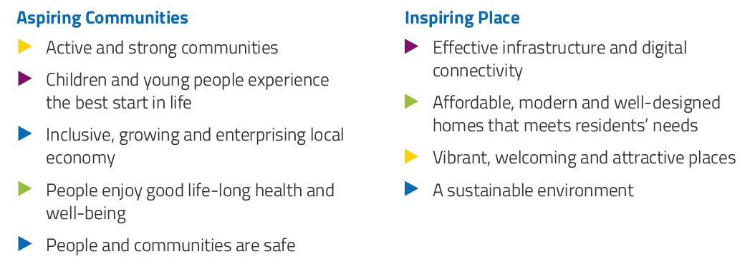

**National Improvement Framework:**

The National Improvement Framework for Education is designed to help us deliver the twin aims of excellence and equity; galvanising efforts and aligning our collective improvement activities across all partners in the education system to address our key priorities. These priorities remain as:

* Improvement in attainment, particularly in literacy and numeracy
* Closing the attainment gap between the most and least disadvantaged children
* Improvement in children and young people’s health and wellbeing
* Improvement in employability skills and sustained, positive school-leaver destinations for all young people

Alignment to Local and National Plans

This plan is aligned to local and national plans as follows:

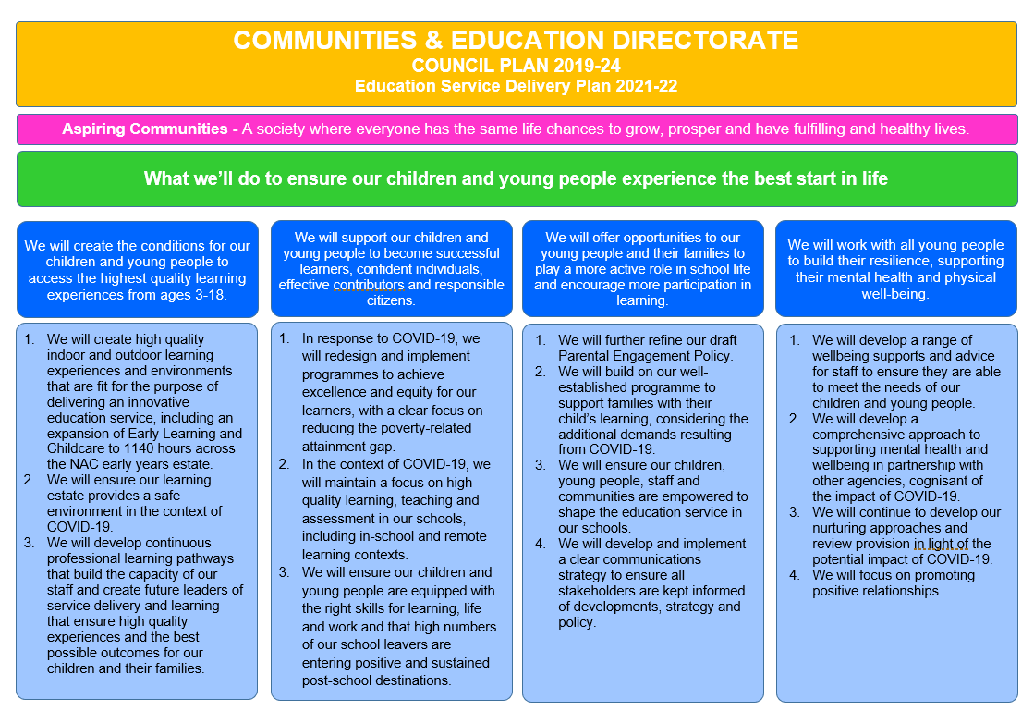

**Strategic Plan 2021-22: Arran High School**

|  |  |  |  |  |  |
| --- | --- | --- | --- | --- | --- |
| **School Priorities** | We will continue to develop the quality of teaching and learning in the school. | We will further improve the quality of our self – evaluation system, processes and procedures, including tracking and monitoring of achievement and identifying gaps in learning. | We will work to further support the health and well - being of our school and community | We will continue to provide enhanced support for pupils to ensure that they achieve a positive and sustained destination |  |
| **High Level Objectives** | * Continuation of our Visible Learning Action Plan and aim that all pupils will make at least one year’s progress for one year’s input, taking account of the challenges arising from Covid 19 * Consistent, high expectations are shared and agreed through engagement with partners, parents, staff and pupils * Continue to support staff learning in relation to their understanding of literacy and numeracy levels and expectations * Within the constraints of Covid 19 seek to provide wider achievement opportunities for pupils. * Continued focus and refinement of blended learning contingencies | * Involve all staff in continuing to refine approaches to self evaluation and moderation within the context of Visible Learning * Continue to look out and engage with other schools in the authority and beyond in the moderation and verification process * Support teachers to improve the quality of their attainment through a targeted approach, reflecting on relevant BGE/standardised data, the curriculum and the principles of HGIOS 4 * Creation of a tracking and monitoring procedure for wider achievement in all stages to target disengaged learners. | * The continued development of a consistent ‘joined up approach’ to the promotion and support for health and wellbeing both within the school and with partners in the community * To continue to support and create professional learning opportunities for all staff and for the wider island community that takes account of restrictions caused by Covid 19. * Further develop understanding and practice of the principles of Nurture for both staff and learners * Continue to promote opportunities for positive physical, emotional and mental health with a particular focus on the positive impact of physical activity and being in the outdoors | Enhanced support to be provided as appropriate for senior phase pupils to ensure that they achieve a positive destination  Position of DYW coordinator to be created in school to provide enhanced opportunities for all pupils to engage with the world of work. |

**Strategic Plan 2021-22: Arran High School**

Here is an overview of how we intend to use our **Pupil Equity Funding** to support improvement:

**Detailed Action Plan 2021-22: Arran High School**

|  |  |  |  |  |  |  |  |
| --- | --- | --- | --- | --- | --- | --- | --- |
| **Establishment Strategic Priority:** | | **\*** W**e will continue to develop the quality of teaching and learning in the school.** | | | | | **Linked to Directorate Priority:** *[insert relevant number(s) 1-4]* |
| **High Level Objectives** | **HGIOS 4**  **NIF** | **Supported through PEF?**  **Y/N** | **How will we achieve this?** | **Timescale / Assigned to:** | **Pupil Outcomes**  *What will change for our learners?* | **Measurement**  *How will we measure impact?* | |
| Continuation of our Visible Learning Action Plan and aim that all pupils will make at least one year’s progress for one year’s input, taking account of the challenges arising from Covid 19  Consistent, high expectations are shared and agreed through engagement with partners, parents, staff and pupils  Continue to support staff learning in relation to their understanding of literacy and numeracy levels and expectations  Within the constraints of Covid 19 seek to provide wider achievement opportunities for pupils, ensuring that opportunities are embedded in the curriculum and in after school activities and trips etc    Continued focus and refinement of blended learning contingencies | *HGIOS 4*  *3.1/2.3/1.3*  *NIF* | ***Y (VL)***  **N**  **Y (Accelerated Reader)**  **N**  **N** | * During In-service days staff will work with consultant from Osiris to refresh CPD and subsequent classroom practice from previous years. * All teachers to refresh pupils’ understandings and awareness of learning dispositions, which will be used in all learning conversations. * All teachers to continue to use learning dispositions in learning conversations * Teachers to focus **on effective feedback** and ensure that this is provided for all learners. * Set up a staff working group to take identified priorities in VL forward as per our plan. * Targetted study of literacy skills during wider achievement time * FL English to present to staff in INSET September 2021 * Refine our wider achievement programme, ensuring that opportunities are embedded in the curriculum during wider achievement afternoons and in after school activities and trips etc. * Staff will continue to share good practice and strategies for teaching on online platforms as appropriate | In-service Day allocation – SLT/VL working group, J Pitt (Osiris)  FL English/English staff  Active schools coordinator/staff volunteers/SLT/members of the community as appropriate (e.g. community land initiative , COAST etc.,) ongoing  All staff – time in FL meetings, staff meetings, INSET given (ongoing) | Learners will be able to learn to their full potential.  All of our learners will be able to apply characteristics of an assessment capable learner and, with the support of their teacher and quality feedback, will be able to understand and be empowered to take the steps they need to take to progress in learning  Learners will benefit from enhanced opportunities within the curriculum for literacy and numeracy and have consistent, high quality support from all teachers.  Pupils will have enhanced opportunities to engage in a variety of experiences and extra-curricular activities.  Pupils will understand and have an active role in promoting rights of the child.  Positive impact on learners’ successes and achievements | Tracking and monitoring data/discussion with learners/parents/audit of classwork and homework/teacher and SLT observation and self-evaluation findings *(see objective 2)* | |

|  |  |  |  |  |  |  |  |
| --- | --- | --- | --- | --- | --- | --- | --- |
| **Establishment Strategic Priority:** | | **\*** We will further improve the quality of our self – evaluation system, processes and procedures, including tracking and monitoring of achievement and identifying gaps in learning. | | | | | **Linked to Directorate Priority:** *[insert relevant number(s) 1-4]* |
| **High Level Objectives** | **HGIOS 4**  **HGIOELC**  **NIF** | **Supported through PEF?**  **Y/N** | **How will we achieve this?** | **Timescale / Assigned to:** | **Pupil Outcomes**  *What will change for our learners?* | **Measurement**  *How will we measure impact?* | |
| Involve all staff in continuing to refine approaches to self- evaluation and moderation within the context of Visible Learning  Continue to look out and engage with other schools in the authority and beyond in the moderation and verification process  Support teachers to improve the quality of their attainment through a targeted approach, reflecting on relevant BGE/standardised data, the curriculum and the principles of HGIOS 4  Creation of a tracking and monitoring procedure for wider achievement in all stages to target disengaged learners. | HGIOS 4  *3.2, 2.3* | **N** | All staff to engage in INSET to consider the importance of self-evaluation and different strategies that will allow us to identify strengths and areas for development in learning and teaching practice  Working group to be established for staff to identify and take forward identified strategies.  Calendared self-evaluation activities and feedback created to feed into our FIP/SIP.  Agreed strategies to be employed across the school. Regular feedback of this in FL meetings.  Continued use of a variety of standardised assessments (e.g. GL) and Accelerated Reader/Compete Maths data to provide evidence which will support teacher judgement and differentiation in teaching and learning.  Continued whole school and faculty collation and moderation to ensure robust evidence to support targets and estimates for SQA. | VL self-evaluation strategies in line with Covid 19 mitigations to be discussed at Inset 1 (September 2021)  Working group to meet in September INSET 2021  SLT/FLs to monotone using agreed calendar (ongoing) | Pupils will benefit from improved learning experiences, leading to improved attainment and outcomes.  Positive impact on learners’ successes and achievements | Attainment data, classroom observation, analysis of feedback, routinely gathered pupil voice, analysis of classwork, feedback from parents.  T&M monitoring calendar in place and monitored  Newspaper and success/achievement board regularly updated | |

|  |  |  |  |  |  |  |  |
| --- | --- | --- | --- | --- | --- | --- | --- |
| **Establishment Strategic Priority:** | | We will continue to provide enhanced support for all pupils to ensure that they achieve a positive destination | | | | | **Linked to Directorate Priority:** *[insert relevant number(s) 1-4]* |
| **High Level Objectives** | **HGIOS 4**  **HGIOELC**  **NIF** | **Supported through PEF?**  **Y/N** | **How will we achieve this?** | **Timescale / Assigned to:** | **Pupil Outcomes**  *What will change for our learners?* | **Measurement**  *How will we measure impact?* | |
| Enhanced support to be provided as appropriate for senior phase pupils to ensure that they achieve a positive destination  Position of DYW coordinator to be created in school to provide enhanced opportunities for all pupils to engage with the world of work. | *HGIOS 4 – 3.3, 2.7,2.7* | *N* | Continued review of options processes to ensure that all pupils are coursed and challenged appropriately  Pupils and parents are actively engaged in transitions at all stages of learning.  Continued review of PSE courses to ensure that all pupils understand and have the tools to negotiate current employment challenges  Regular, quality engagement with SDS and other partners as appropriate to ensure that all students are given the fullest and most appropriate support  Continued review of wider achievement opportunities to ensure that achievement is formally recognised and accreditation given as appropriate  Temporary position of DYW coordinator (0.4) is filled and ring-fenced. Plan is devised and monitored to ensure impact. | DHT/FLs by December 2021  Ongoing  FL pastoral support/DHT (ongoing)  Ongoing with SDS team and DHT  By August 2021 – review by December 2021  August 2021 | Pathways to further and higher education and employment are clearly and timeously identified and form part of the options process for learners.  Students have more awareness of challenges and develop strategies and resilience to move forward to a positive destination  Enhance opportunities and support are provided for all pupils to experience and engage with the real world of work both on the island and further afield. | *Student voice*  *Review of destination data (Insight)*  *Data from uptake of wider achievement activities etc.,*  *Student/partner/parent evaluation of provision*  *Staff feedback in relation to increased confidence in identifying and being explicit about learning pathways*  *Evaluation of DYW strategic plan and impact (see separate sheet)* | |

|  |  |  |  |  |  |  |  |  |
| --- | --- | --- | --- | --- | --- | --- | --- | --- |
| **Establishment Strategic Priority:** | | **\*** We will work to further support the health and well - being of our school and community | | | | | | **Linked to Directorate Priority:** *[insert relevant number(s) 1-4]* |
| **High Level Objectives** | **HGIOS 4**  **HGIOELC**  **NIF** | **Supported through PEF?**  **Y/N** | **How will we achieve this?** | **Timescale / Assigned to:** | **Pupil Outcomes**  *What will change for our learners?* | | **Measurement**  *How will we measure impact?* | |
| The continued development of a consistent ‘joined up approach’ to the promotion and support for health and wellbeing both within the school and with partners in the community  To continue to support and create professional learning opportunities for all staff and for the wider island community that takes account of restrictions caused by Covid 19.  Further develop understanding and practice of the principles of Nurture for both staff and learners  Continue to promote opportunities for positive physical, emotional and mental health with a particular focus on the positive impact of physical activity and being in the outdoors | HGIOS 4 – 3.1, 3.2 | *N* | Introduction of Listen Well programme and ‘step up to listen’  Continued refinement of the peer mentor programme to be set up and led by senior prefects  Introduction of Active Minds programme  ‘Duke of Edinburgh’ award built into curriculum as part of wider achievement | *By December 2021 (SLT/nurture staff, FL Pastoral Support/teaching staff and appropriate partners)* | | Skills in active listening developed. Improvement in peer communication.  Positive impact on mental resilience and wellbeing of pupils.  Learners’ awareness of the importance of mental health is increased and backed up with sustainable and consistent support. Further focus on mental health and nurturing practice for learners  Increased opportunity to volunteer, develop skills outdoors, build independence and confidence | Questionnaires, achievement and participation data, feedback from pupil voice, numbers participating in physical activity.  As a SHINE school, the mental health and wellbeing survey will allow us to inform strategy (and GL Pass survey information – October 2021) | |

|  |  |  |  |  |  |  |  |
| --- | --- | --- | --- | --- | --- | --- | --- |
| **Establishment Strategic Priority:** | | **\*** We will work to further enhance the partnership between the school, parents and the wider community. | | | | | **Linked to Directorate Priority:** *[insert relevant number(s) 1-4]* |
| **High Level Objectives** | **HGIOS 4**  **HGIOELC**  **NIF** | **Supported through PEF?**  **Y/N** | **How will we achieve this?** | **Timescale / Assigned to:** | **Pupil Outcomes**  *What will change for our learners?* | **Measurement**  *How will we measure impact?* | |
| Audit of parental partnership in the school to understand their needs and how we can improve communication.  Encourage the activities of a parent council. | *HGIOS 4 – 2.5/2.7/3.1* | *N* | Survey parents to ascertain what they would like the school to provide in terms of twilight meetings/drops in to allow them to understand our curriculum/processes better  Establish a clear conduit of communication with parents via a monthly newsletter/ updated website/ SMHW/calendared drop-in sessions with SLT  Encourage further involvement of Parent Council | Calendared times (to be decided, then ongoing)  *Fortnightly and ongoing*  *ongoing* | Pupils will benefit from increased collaboration between school and home and family learning.  More families engaged in participation in designing and delivering our curriculum.  Better outcomes for pupils through collaborative programmes  School will better understand how to meet pupils’ needs and provide targeted support | Questionnaires, participation numbers in collaborative working opportunities, feedback from parents, parents evenings etc., | |